

**Medical Center**

|  |  |  |
| --- | --- | --- |
| **Supervisor:** | *LÊ THANH NHÂN* | |
| **Semester:** | *II* | |
| **Batch No:** | *T5.2306.E1* | |
| **Group No:** | *04* | |
| **Order:** | **Full name** | **Roll No.** |
| *1.* | *Nguyễn Minh Hoàng* | *Student1345179* |
| *2.* | *Ngô Thái Vĩnh* | *Student1269826* |

***Month****:04* ***Year****:2024*



This is to certify that

|  |  |
| --- | --- |
| **Mr.** | **NGUYEN MINH HOANG** |
| **Mr.** | **NGO THAI VINH** |

Have successfully Designed & Developed:

|  |  |  |
| --- | --- | --- |
|  |  |  |
| **Medical Center** | | |

Submitted by:

|  |
| --- |
| **Mr. LE THANH NHAN** |

Date Of Issue:

|  |  |
| --- | --- |
|  |  |

Authorized Signature:

|  |  |
| --- | --- |
|  |  |
| **Content** | | | |

Content 2

Acknowledge 4

Synopsis 5

Review1 7

Review2 11

Review3 24

Testting Document 32

Final Checklist 33

Tasksheet 34

|  |
| --- |
| **Acknowledge** |

First and foremost, we would like to express our deepest appreciation to our admirable instructor – Mr. LE THANH NHAN. During the time of the project, he continually and convincingly conveyed a spirit of adventure in regard to research and scholarship, and an excitement in regard to teaching. Without his guidance and persistent help, this project would not have been possible. Therefore, once again, we truly value your dedication and guidance, Mr. NHAN.

Next, it would have been impossible to carry out and complete this project without the collaboration among our team members. Although we have gone through many obstacles during the project implementation, eventually, we gained what we aimed at by our hard work, our strong commitment, and of course, our brotherhood.

Finally, thanks to Aptech’s e-Project team, we had a golden opportunity to apply what we have learned into reality and gain hands-on experience which is essential for our future

|  |
| --- |
| **Synopsis** |

The Medical Center System is a robust platform tailored to streamline administrative processes and elevate operational efficiency within medical facilities. This comprehensive solution encompasses features such as user authentication, patient and staff management, transaction recording, billing, and reporting, empowering healthcare professionals to prioritise patient care.

Characterised by an intuitive interface and user-friendly navigation, the system ensures accessibility and ease of use for all personnel, facilitating seamless access to critical information and functionalities. From maintaining comprehensive patient records to facilitating financial transactions and generating insightful reports, the system caters to the multifaceted needs of medical centres.

The project acknowledges the collaborative efforts of the project team, clients, testers, stakeholders, and end-users in realising the Medical Center System. Their dedication, expertise, and support have been pivotal in achieving project objectives and ensuring its success.

In summary, the Medical Center System represents a significant stride in medical administration, promising heightened efficiency, precision, and quality in patient care delivery

**Review 01**

|  |
| --- |
| **Problem Definition** |

1. The healthcare industry faces challenges in efficiently managing patient information, appointments, transactions, and billing. To address these challenges, our project aims to develop a Healthcare Management System using JavaFX. The system will provide the following functionalities:
2. Authentication and Employee Verification: Implement a secure authentication system to ensure that only authorized personnel can access the system.
3. Graphical User Interface (GUI): Design an intuitive GUI with a dynamic menu interface to facilitate easy navigation and interaction for users.
4. PMC Employee Functions: Enable PMC staff to perform essential tasks such as adding, viewing, editing, and deleting information related to doctors and patients.
5. Transaction Management: Allow PMC staff to record patient consultations, diagnoses, treatments, and other relevant transactions accurately.
6. Billing and Invoice Generation: Provide functionality for PMC staff to create and print invoices for patient services rendered.
7. Data Query and Reporting: Develop features that allow PMC staff to query various data points such as patient visit counts, doctor counts, and other relevant metrics for reporting and analysis purposes.
8. Application Exit Feature: Include an option for users to gracefully exit the application when they have completed their tasks.

|  |
| --- |
| **Customer Requirements Specifications** |

1. **CRS/Requirements Specifications**

|  |  |  |
| --- | --- | --- |
| Client/Project Undertaken: | | |
| 1. | List of inputs to the system | |
|  | *-* | Authentication credentials (username, password) for logging in. |
|  | *-* | Information about doctors and patients (names, contact details, medical history, etc.). |
|  | *-* | Details of patient consultations, diagnoses, treatments, and transactions. |
|  | *-* | Billing information including services rendered and associated costs. |
|  |  |  |
| 2. | List of outputs expected from the system | |
|  | *-* | Successful login confirmation or authentication failure message. |
|  | *-* | Display of doctor and patient information. |
|  | *-* | Generation and printing of invoices for patient services. |
|  | *-* | Query results such as patient visit counts, doctor counts, and other relevant metrics. |
|  | *-* | Reports based on queried data for analysis purposes. |
|  |  |  |
| 3. | Overview of processes involved in the system | |
|  | - | Authentication and authorization of users. |
|  | - | Management of doctor and patient information. |
|  | - | Recording patient consultations, diagnoses, treatments, and transactions. |
|  | - | Billing and invoice generation for patient services. |
|  | - | Data querying for retrieving specific information. |
|  | - | Report generation for analysis and decision-making purposes. |

|  |  |  |
| --- | --- | --- |
| Admin/Project Undertaken: | | |
| 1. | List of inputs to the system | |
|  | *-* | Administrative login credentials.Access control settings for different user roles. |
|  | *-* | Access control settings applied to user roles. |
|  | *-* | System configuration confirmation messages. |
|  |  |  |
| 2. | List of outputs expected from the system | |

|  |  |  |
| --- | --- | --- |
|  | *-* | Admin login confirmation or authentication failure message. |
|  | *-* | Access control settings applied to user roles. |
|  | *-* | System configuration confirmation messages. |
|  |  |  |
| 3. | Overview of processes involved in the system | |
|  | - | Admin authentication and authorization. |
|  | - | Configuration of access control settings for different user roles. |
|  | - | System configuration management to ensure smooth operation and security. |
|  |  |  |

|  |  |
| --- | --- |
| Hardware and software required for implementing the project | |
| 1 | Operating system: Windows 10 higher |
| 2 | Hardware: CPU Cores with 2 Gigabytes of RAM or better |
| 3 | Font Unicode: Arial, Tahoma, Lucida Console, Times New Roman, etc… |
| 4 | Other requirement: A working internet connection |

**CRS/Customer Acceptance Criteria**

|  |  |
| --- | --- |
| **S.No** | **Customer's Acceptance Criteria** |
| 1 | Valid login credentials when logging in then grant access or display authentication failure. |
| 2 | System access when viewing doctor info then displays doctor details. |
| 3 | System access when adding patient info then store details. |
| 4 | System access when recording patient transactions then log accurately. |
| 5 | System access when generating patient invoices then list services and costs. |

1. **Project Plan**

|  |  |
| --- | --- |
| 1. Project Details | |
| + | Name of the Client: Medical Center |
| + | Date of Project Plan: 16 April 2024 |
| + | Project Vision/Objectives: |
|  | Due to its good service and fame, the number of patients visiting the doctors at the center is increasing day by day. With the constant rise in the patients, the staff of PMC find it difficult to take care of the daily transactions.  The management of PMC has decided to automate the entire system which will reduce the staff effort. |
|
|
| + | Scope: |
|  | The Desktop application helps the medical center by managing doctors’ appointments, patients’ billing, treatment history, diagnostics information, and administrative activities, managing patient information , doctor information. |
| + | Our understanding of the client organization: |
|  | Philadelphia Medical Center (PMC) is one of the leading medical centers in Great Lakes Region, United States of America (USA). Most of the doctors in that area conduct their private practice in PMC. The treatment given by the medical center is believed to be one of the best and it has good service. |
| + | Project Organization with Responsibilities and Authorities: |
|  | Analyst, Designer, Developer, Tester, Implementation Engineer, Maintenance Engineer |
| 2. Project Initiation/Requirement Documents | |
|  | - Design Documentation  - Installation Guide  - User Guide |

**Review 02**

|  |
| --- |
| **Architecture and design of the Application** |

1. **Application Architecture**

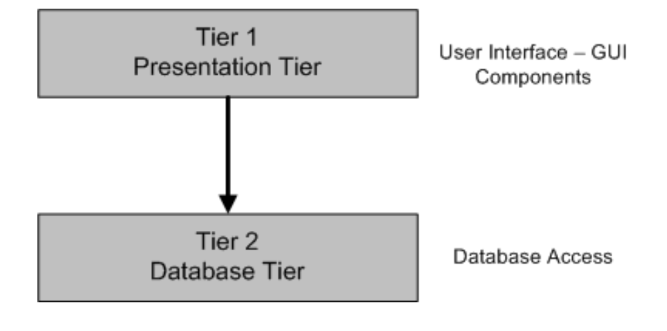

Figure 1.1: Two-Tier Architecture of the Project

1. **Data Flow Diagram**

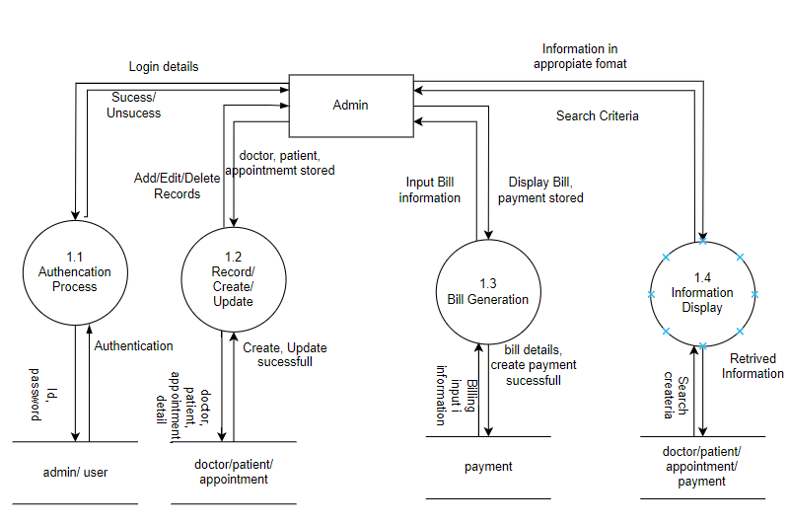

Figure 1.3: DFD Level 1 - Main Processes of Admin ( Staff)

|  |
| --- |
| **Entity Relationship Diagram** |

1. **ERD**

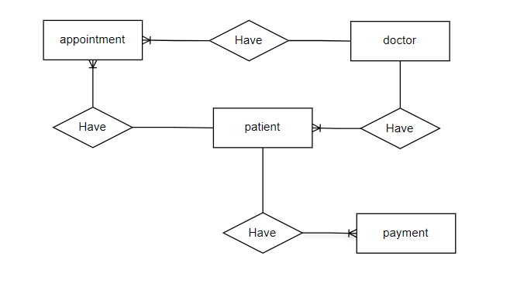

1. **ERD Properties**
   * + 1. **Admin**

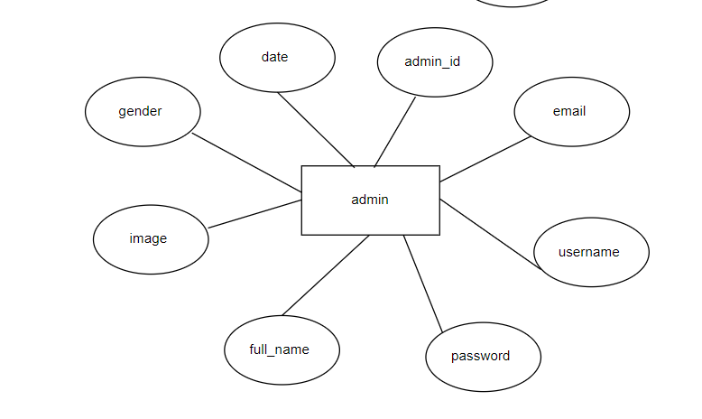

* + - 1. **Doctor**

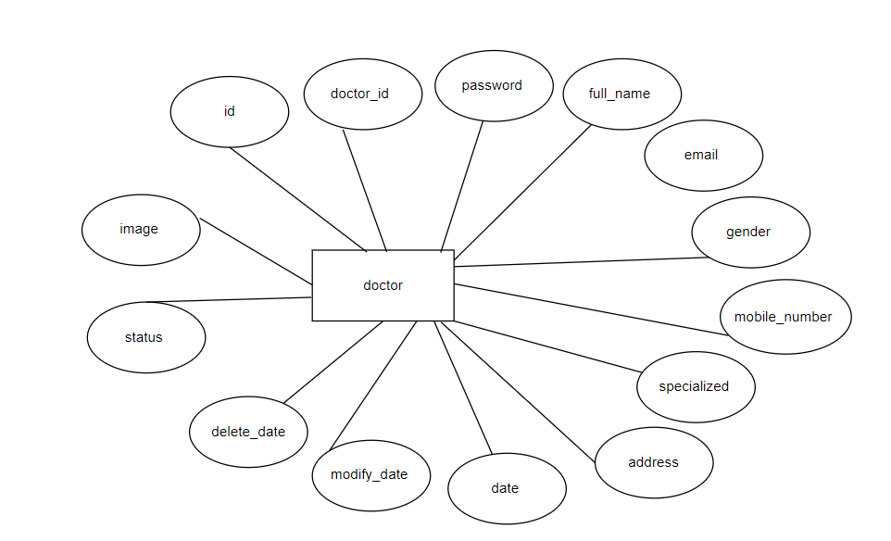

* + - 1. **Patient**

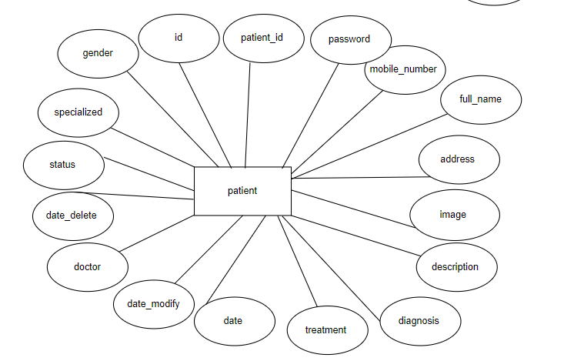

* + - 1. **Appointment**

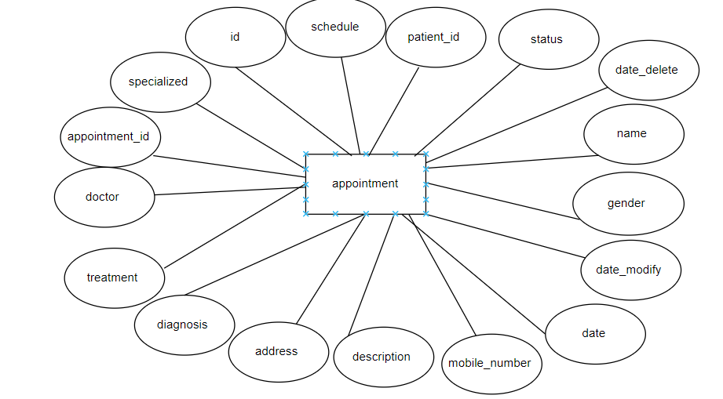

* + - 1. **Payment**

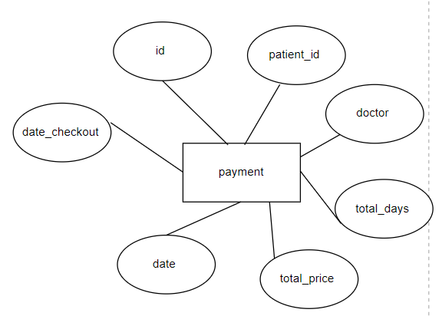

|  |
| --- |
| **Table Design** |

1. **Table Design**
   * + 1. **Admin**

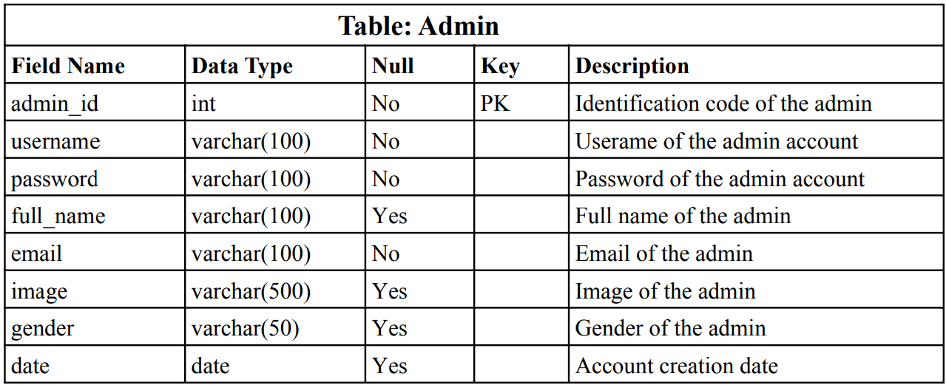

* + - 1. **Doctor**

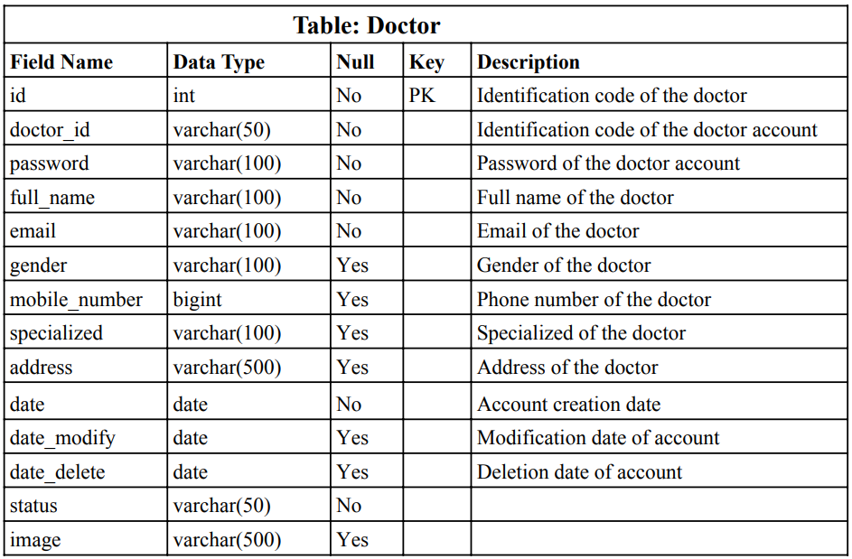

**Patient**

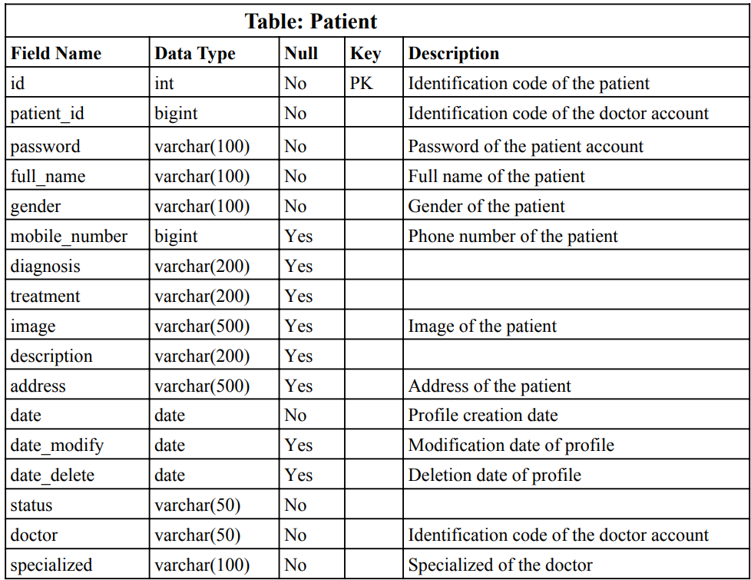

* + - 1. **Appointment**

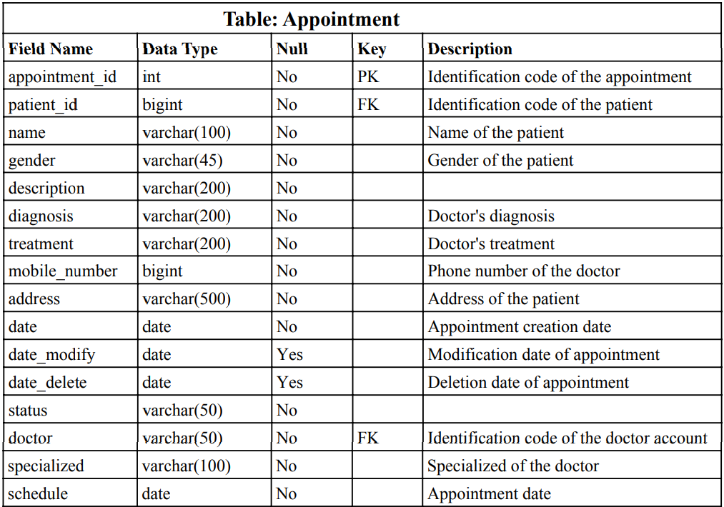

* + - 1. **Payment**

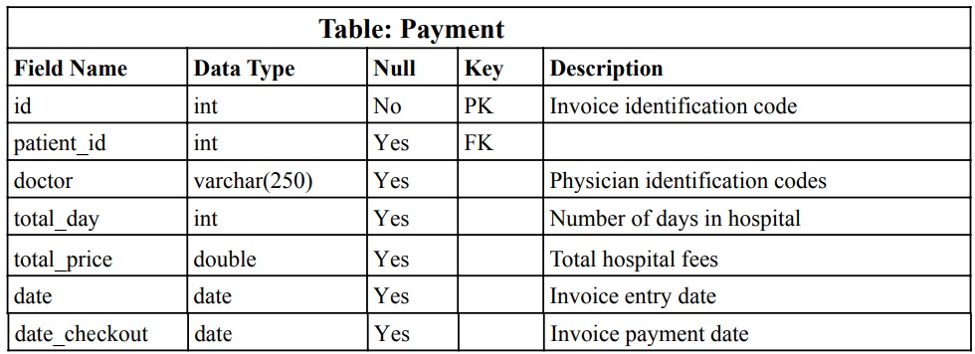

1. **Relationship Diagram**

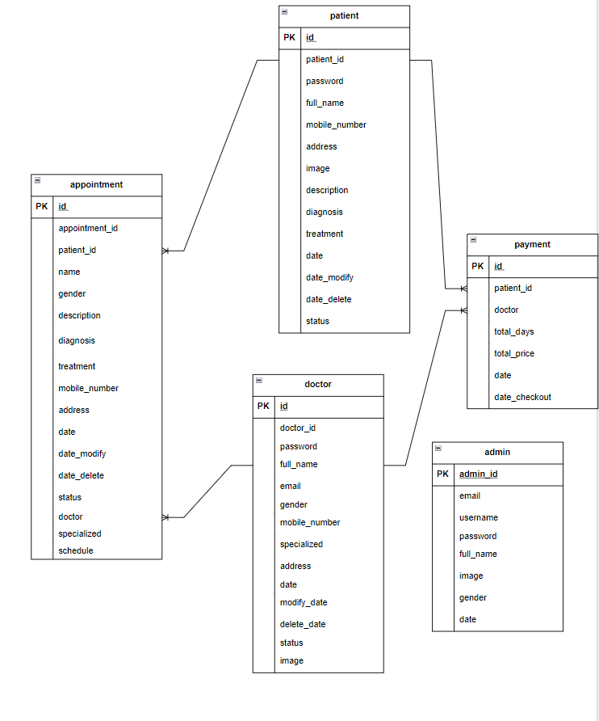

|  |
| --- |
| **Algorithm** |

1. **Administraror**

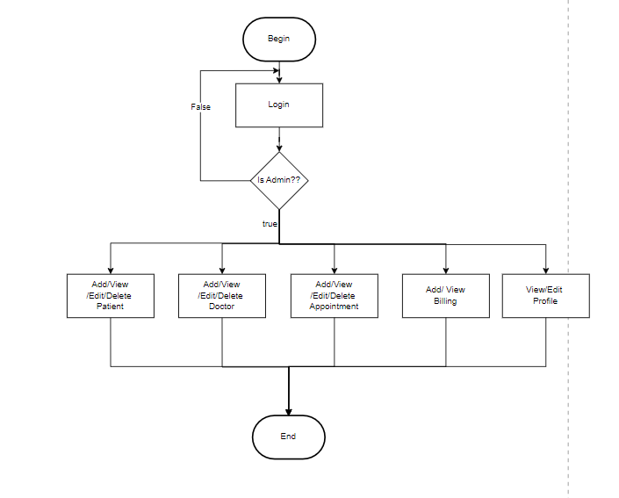

1. Doctor

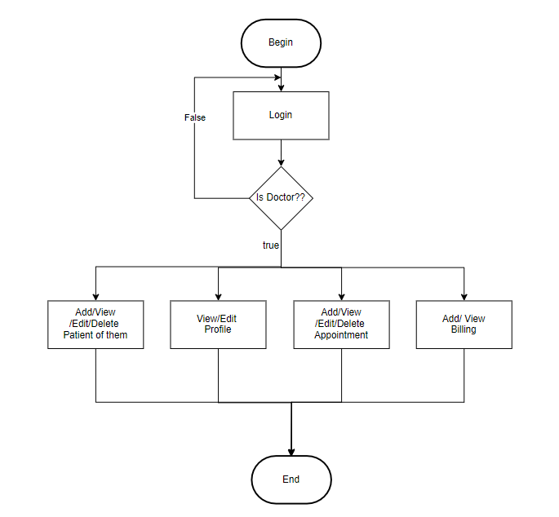

**Review 03**

|  |
| --- |
| **Screen shots** |

* 1. **Login Page**

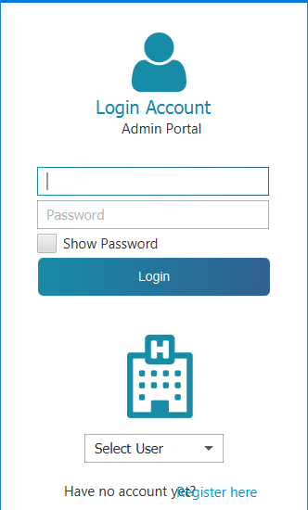

**Description** :  Login

|  |  |
| --- | --- |
| **Properties** | **Value** |
| Document theme and color scheme | #fff |
| Form - Background color | #fff |
| Title - Font Size | 20px |
| Title - Font Color | #188ba7 |
| Title - Font Style | Tahoma |
| Title - Alignment | Center |
| Background color of Controls on the form | #FFF |
| Control Caption - Font size | 12px |

* 1. **Dash Board**

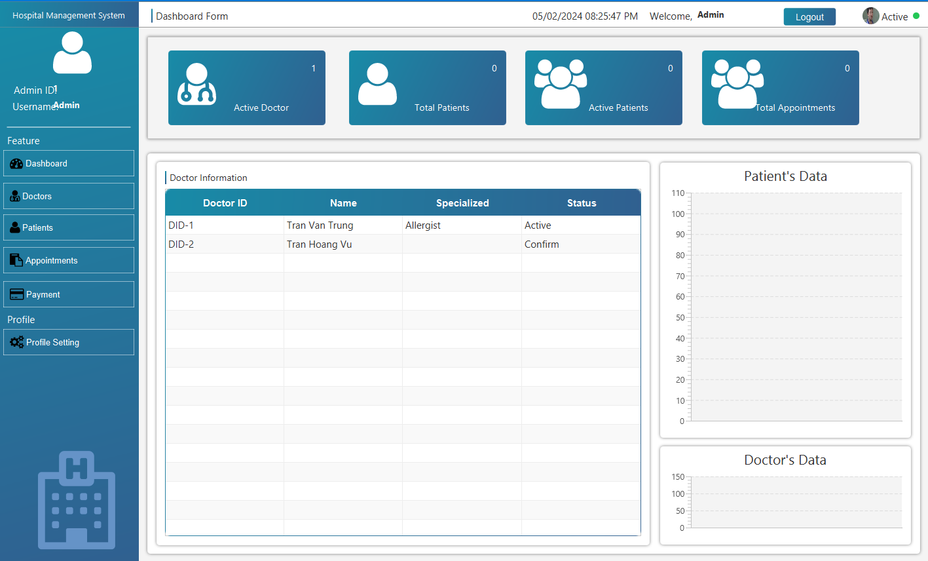

**Description :** Dashboard and Chart

**From :** Login

**To :** Staff Management (Admin), Doctors and Patients Management (Staff), Appoiment Manager, Payment Manager, Profile Page, Logout Account

|  |  |
| --- | --- |
| **Properties** | **Value** |
| Document theme and color scheme | #fff |
| Form - Background color | #fff |
| Title - Font Size | 15px |
| Title - Font Color | #000 |
| Title - Font Style | System |
| Title - Alignment | Left |
| Background color of Controls on the form | #FFF |
| Control Caption - Font size | 14px |
| Control Caption - Font Color | #000 |
| Control Caption - Font Style | System |
| Control caption and controls - Alignment | Left |
| Command button - Alignment | Center |

* 1. **Doctor Manager**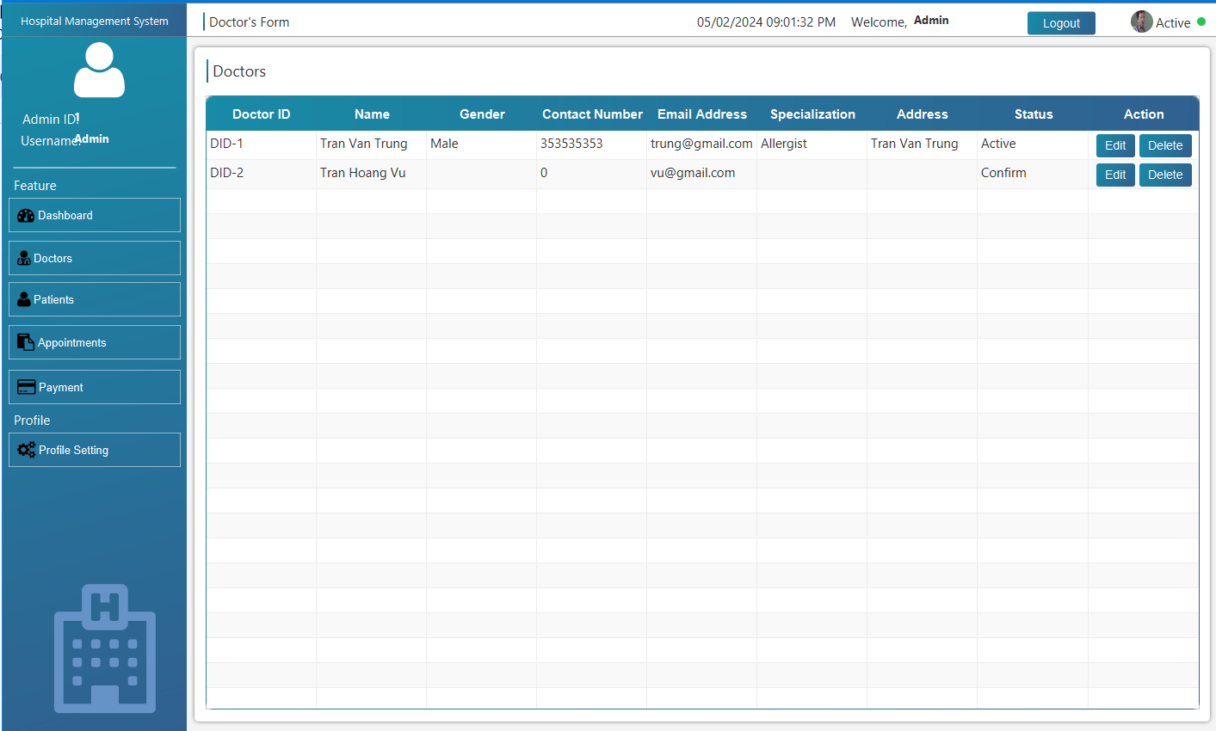

**Description :** Doctor List

**From :** Dashboard

**To :** Edit/Delete Doctor Information

|  |  |
| --- | --- |
| **Properties** | **Value** |
| Document theme and color scheme | #fff |
| Form - Background color | #fff |
| Title - Font Size | 15px |
| Title - Font Color | #000 |
| Title - Font Style | System |
| Title - Alignment | Left |
| Background color of Controls on the form | #FFF |
| Control Caption - Font size | 14px |
| Control Caption - Font Color | #000 |
| Control Caption - Font Style | System |
| Control caption and controls - Alignment | Left |
| Command button - Alignment | Center |

* 1. **Patient Manager**

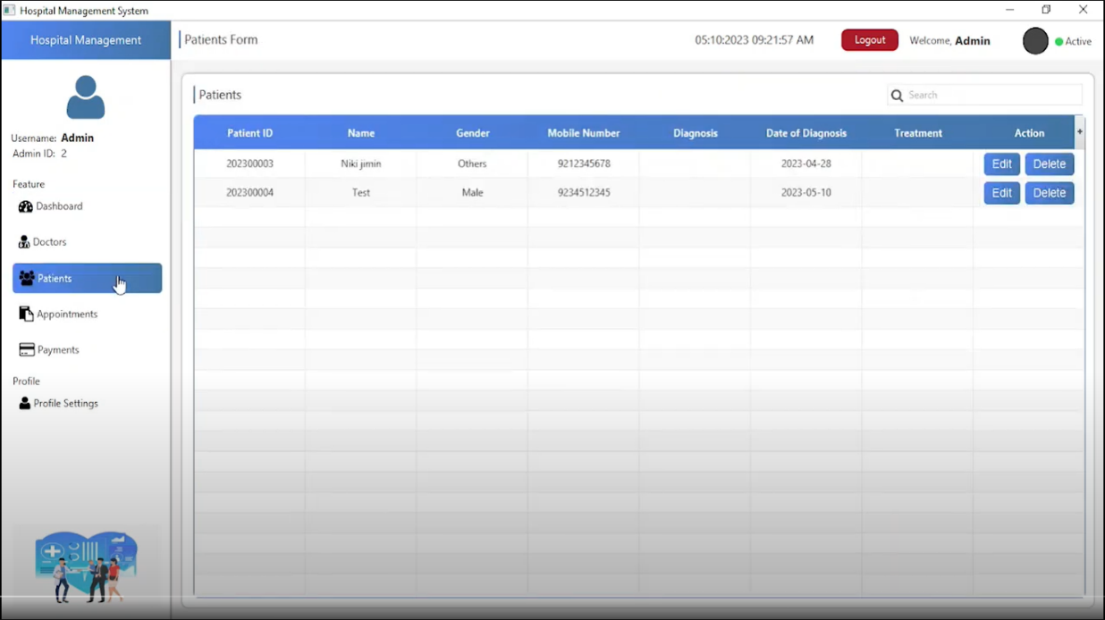

**Description :** Patients List

**From :** Dashboard

**To :** Edit/Delete Patient Information

|  |  |
| --- | --- |
| **Properties** | **Value** |
| Document theme and color scheme | #fff |
| Form - Background color | #fff |
| Title - Font Size | 15px |
| Title - Font Color | #000 |
| Title - Font Style | System |
| Title - Alignment | Left |
| Background color of Controls on the form | #FFF |
| Control Caption - Font size | 14px |
| Control Caption - Font Color | #000 |
| Control Caption - Font Style | System |
| Control caption and controls - Alignment | Left |
| Command button - Alignment | Center |

* 1. **Edit Patient Information**

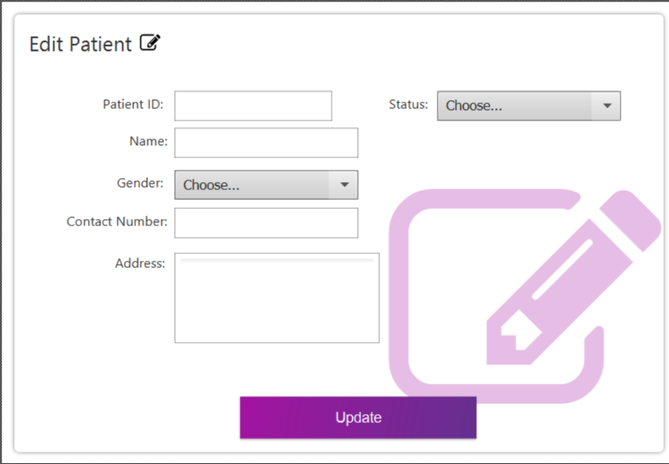

**Description**: Edit Patient Information

**From** : Dashboard

**To** : Patients List

|  |  |
| --- | --- |
| **Properties** | **Value** |
| Document theme and color scheme | #FFF |
| Form - Background color | #000 |
| Title - Font Size | 15px |
| Title - Font Color | #FFF |
| Title - Font Style | System |
| Title - Alignment | Left |
| Background color of Controls on the form | #FFF |
| Control Caption - Font size | 14px |
| Control Caption - Font Color | #000 |
| Control Caption - Font Style | System |
| Control caption and controls - Alignment | Left |
| Command button - Alignment | Center |

* 1. **Appointment Manager**

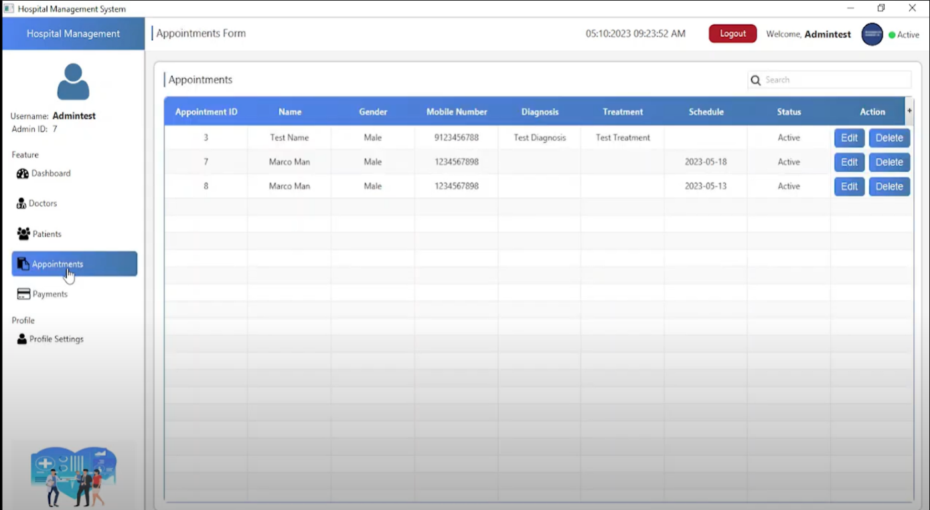

**Description :** Appointment List

**From :** Dashboard

**To :** Edit/Delete Appointment Information

|  |  |
| --- | --- |
| **Properties** | **Value** |
| Document theme and color scheme | #FFF |
| Form - Background color | #000 |
| Title - Font Size | 15px |
| Title - Font Color | #FFF |
| Title - Font Style | System |
| Title - Alignment | Left |
| Background color of Controls on the form | #FFF |
| Control Caption - Font size | 14px |
| Control Caption - Font Color | #000 |
| Control Caption - Font Style | System |
| Control caption and controls - Alignment | Left |
| Command button - Alignment | Center |

* 1. **Edit Profile**

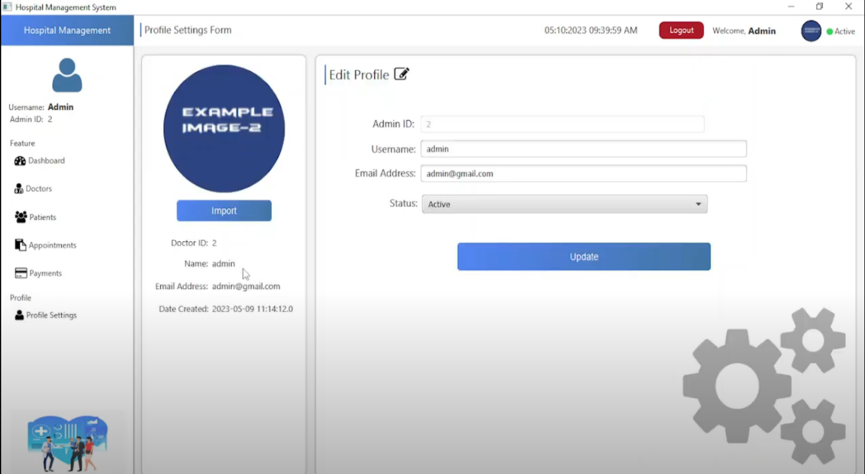

**Description** : Profile

**From**  : Dashboard

**To** : Edit Profile

|  |  |
| --- | --- |
| **Properties** | **Value** |
| Document theme and color scheme | #fff |
| Form - Background color | #fff |
| Title - Font Size | 15px |
| Title - Font Color | #000 |
| Title - Font Style | System |
| Title - Alignment | Left |
| Background color of Controls on the form | #FFF |
| Control Caption - Font size | 14px |
| Control Caption - Font Color | #000 |
| Control Caption - Font Style | System |
| Control caption and controls - Alignment | Left |
| Command button - Alignment | Center |

|  |
| --- |
| **Testing document** |

|  |  |  |
| --- | --- | --- |
| **Sr.No** | **Features Tested** | **Remarks** |
| 1 | Test case | Pass |
| 2 | Test plan | Pass |
| 3 | Test scenario | Pass |
| 4 | Test report | Pass |
| 5 | Requirements Specification | Pass |
| 6 | Functional Specification | Pass |
| 7 | Use-Case Reports | Pass |
| 8 | Project Plan | Pass |
| 9 | Design Specifications | Pass |
| 10 | Prototype | Pass |
| 11 | User’s Manuals | Pass |
| 12 | Business Functions and Rules | Pass |
| 13 | Project or Business Risk Assessment | Pass |
| 14 | Responsibilities | Pass |
| 15 | Approvals | Pass |

|  |
| --- |
| **Final checklist** |

|  |  |  |
| --- | --- | --- |
| **Sr.No** | **Aspected Tested** | **Suggestion/**  **Remarks** |
| 1 | Can admin add, see, edit, delete doctor? |  |
| 2 | Can admin add, see, edit, delete patient? |  |
| 3 | Can admin add, see Appointment? |  |
| 4 | Is the application user-friendly? |  |
| 5 | Are all the forms validated? |  |
| 6 | Does the management page take too long to be loaded fully? |  |
| 7 | Is the JavaScript code working as expected in all click events? |  |

|  |  |  |  |  |  |  |  |  |
| --- | --- | --- | --- | --- | --- | --- | --- | --- |
| **No** | **Member** | **Contents** | | **Table Name** | **Activity Plan** | **Date of Preparation of Activity Plan** | | |
| **Planned Start Date** | **Actual Start Date** | **Actual Days** | **Status** |
| 1 | **Ngo Thai Vinh** |  | *Doctor Login* | doctor appointment | 16/04/2024 | 16/04/2024 | 5 | ok |
| 2 | *Doctor Register* | 22/04/2024 | 22/04/2024 | 5 | ok |
| 3 |  | *Patient Management* | 28/04/2024 | 27/04/2024 | 5 | ok |
| 4 | *Appointment Management* | 04/05/2024 | 04/05/2024 | 5 | ok |
| 1 | **Nguyen Minh Hoang** |  | *Admin Login* | patient admin  payment | 16/04/2024 | 16/04/2024 | 5 | ok |
| 2 | *Admin Register* | 21/04/2024 | 21/04/2024 | 5 | ok |
| 3 |  | *Doctor Managerment* | 27/04/2024 | 28/04/2024 | 5 | ok |
| 4 | *Bill managagement* | 05/05/2024 | 05/04/2024 | 5 | ok |